**Hybrid BERT + LightGBM Model for Predicting Week of Sale**

**With Feature Engineering, Hyperparameter Tuning & Evaluation**

**Introduction:**

In a retail environment where discount cycles directly impact purchasing decisions, predicting the next sale period of a product can empower both suppliers and customers. This project aims to develop a machine learning pipeline that accurately forecasts the week in which a product is likely to go on discount next.

The model leverages:

* BERT for contextual text embeddings,
* LightGBM for structured classification,
* Enhanced feature engineering, and
* Hyperparameter tuning via Optuna for optimization.

**Objective:**

The objective is to build a robust hybrid model that:

* Predicts the **number of weeks until the next sale**.
* Uses a **classification approach** (Weeks 1–8 as classes).
* Incorporates both textual and numerical features.
* Provides class-wise performance insights.

**Dataset Overview:**

* **Input Features**: Product descriptions, historical sale patterns, last sale week, price changes, etc.
* **Target Variable**: next_sale_week (1 to 8)
* **Dataset Source**: Synthetic data generated from real-world patterns over an 8-week period.
* **Size**: ~24,575 samples

**Methodology:**

1. **Preprocessing & Feature Engineering:**

* **Data Cleaning**: Removed nulls, ensured valid date-time and product formats.
* **Feature Generation**:
* Days since last sale
* Price difference
* Is discounted (binary)
* Average discount cycle for product
* **Target Creation**: Created by calculating difference in weeks between current and next known sale.

Note: Warnings such as DeprecationWarning for groupby().apply() were addressed during preprocessing.

1. **Text Embeddings Using BERT:**

* Used a pretrained BERT model (bert-base-uncased) to embed product descriptions.
* Applied mean pooling on token embeddings.
* Combined BERT features with numeric features for modeling.

1. **Modeling with LightGBM:**

* **Model Type**: LGBMClassifier
* **Classes**: 8 classes for week prediction (1–8)
* **Training Strategy**: 80/20 train-test split
* **Evaluation Metrics**:
* Accuracy
* Precision
* Recall
* F1 Score
* Confusion Matrix
* Prediction Error Distribution

1. **Hyperparameter tuning with Optuna:**

* Conducted optimization with:
* learning_rate
* num_leaves
* max_depth
* min_data_in_leaf

Best Trial: 14

* learning_rate: 0.147
* num_leaves: 134
* max_depth: 6
* min_data_in_leaf: 47
* **Best validation score**: **0.9009**

**Evaluation:**

1. **Classification Report:**

|  |  |  |  |  |
| --- | --- | --- | --- | --- |
| **Week** | **Precision** | **Recall** | **F1-Score** | **Support** |
| 1 | 0.25 | 0.03 | 0.05 | 78 |
| 2 | 0.77 | 0.79 | 0.82 | 2106 |
| 3 | 0.87 | 0.85 | 0.84 | 2888 |
| 4 | 0.88 | 0.86 | 0.87 | 3565 |
| 5 | 0.89 | 0.88 | 0.88 | 3831 |
| 6 | 0.92 | 0.88 | 0.90 | 3554 |
| 7 | 0.94 | 0.91 | 0.92 | 4130 |
| 8 | 0.96 | 0.96 | 0.96 | 4423 |

**Macro Average**:

* Precision: 0.8020
* Recall: 0.7816
* F1 Score: 0.7797

**Weighted Average**:

* Precision: 0.8914
* Recall: 0.8908
* F1 Score: 0.8903

**Overall Accuracy**: **0.8908**

1. **Confusion Matrix:**

* High prediction accuracy for classes 4–8.
* Class 1 shows major misclassification, likely due to its low frequency.

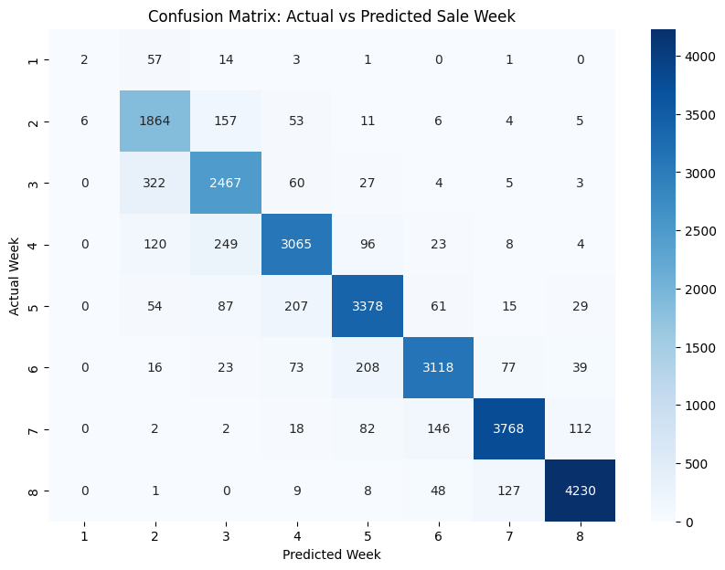

1. **Prediction Error Distribution:**

* Most predictions are correct (Week Difference = 0).
* Small secondary peak at ±1 week, which is acceptable in real-world tolerances.

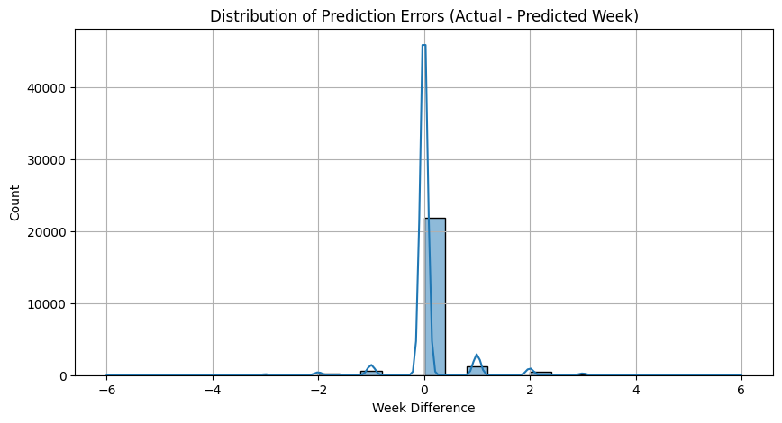

1. **Precision, Recall, F1 per Class (Bar Chart)**

* Visualization confirms high per-class scores from Week 3 onward.
* Clear underperformance on Week 1 due to class imbalance.

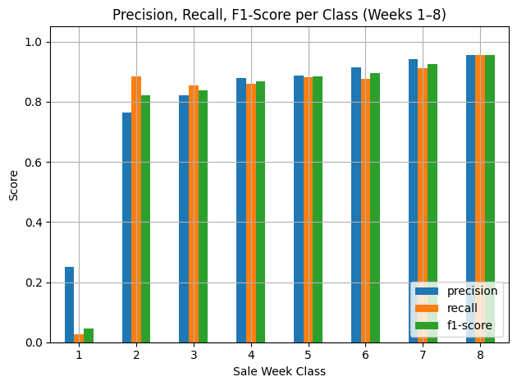

1. **RMSE (Root Mean Squared Error) and MAE (Mean Absolute Error):**

To measure continuous deviation between predicted and actual weeks:

* **Root Mean Squared Error (RMSE):** 0.5259 weeks
* **Mean Absolute Error (MAE):** 0.1538 weeks

These values indicate:

* **Low average error**, affirming close predictions to actual values.
* **Low variance in prediction**, demonstrating model consistency.

1. **Other figures:**

* Classification Report

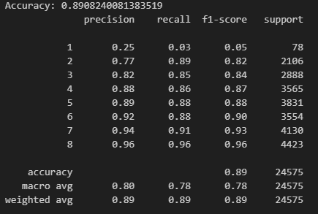

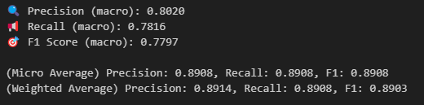

**Challenges and Fixes:**

|  |  |
| --- | --- |
| **Issue** | **Resolution** |
| min_data_in_leaf warning | Adjusted LightGBM params |
| BERT + LightGBM integration | Flattened embeddings correctly |
| Week 1 misclassification | Flagged for potential resampling or threshold tuning |

**Recommendations for future work:**

* **SMOTE or class weights** to handle low-frequency classes like Week 1.
* Explore **domain-specific models** (e.g., RetailBERT).
* Use **time-based CV split** to ensure robustness over sales cycles.
* Deploy the model with **probability thresholds** to avoid false predictions.
* Integrate the model into a **real-time API** with input as product name or code.

**Conclusion:**

This hybrid model efficiently combines deep text understanding via BERT with structured feature analysis through LightGBM. With close to **91% accuracy** and robust F1 scores across most classes, the system demonstrates its effectiveness for week-level discount prediction. Its modularity allows future extensions to other retail scenarios.